Information and dataset for Level 1

1. Level 1 algorithm

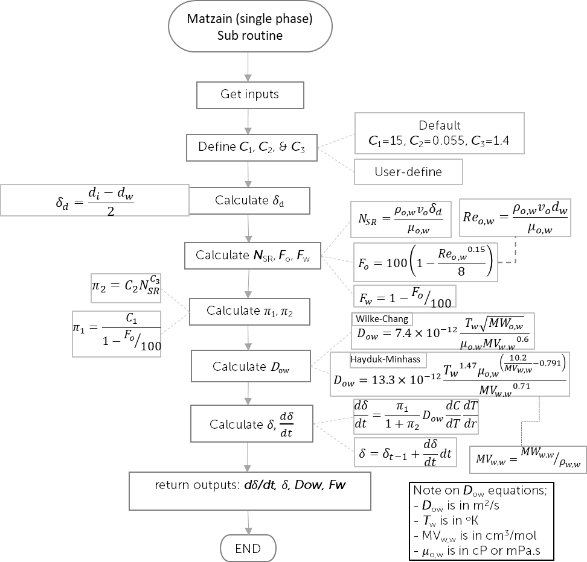

1. Fluid and wax files from selected waxy crude oil

As per attached

1. Coolant table

|  |  |  |  |  |
| --- | --- | --- | --- | --- |
| Temperature | Density | Dynamic Viscosity | Specific heat (Cp) | Conductivity (k) |
| C | kg/m3 | Pa.s | J/kg.K | W/m.K |
| 5 | 1000 | 0.001519 | 4200 | 0.5576 |
| 10 | 999.7 | 0.001307 | 4188 | 0.5674 |
| 15 | 999.1 | 0.001138 | 4184 | 0.5769 |
| 20 | 998.2 | 0.001002 | 4183 | 0.5861 |
| 21 | 998.0 | 0.000980 | 4183 | 0.5878 |
| 25 | 997.1 | 0.0008905 | 4183 | 0.5948 |
| 27.76 | 996.3 | 0.000839 | 4183.000000 | 0.599326 |
| 30 | 995.7 | 0.0007977 | 4183 | 0.603 |
| 30.64 | 995.5 | 0.000788 | 4183.000000 | 0.603986 |
| 35 | 994 | 0.0007196 | 4183 | 0.6107 |
| 40 | 992.2 | 0.0006533 | 4182 | 0.6178 |
| 45 | 990.2 | 0.0005963 | 4182 | 0.6244 |
| 50 | 988 | 0.0005471 | 4181 | 0.6305 |
| 55 | 985.7 | 0.0005042 | 4182 | 0.636 |
| 60 | 983.2 | 0.0004666 | 4183 | 0.641 |
| 65 | 980.6 | 0.0004334 | 4184 | 0.6455 |
| 70 | 977.8 | 0.000404 | 4187 | 0.6495 |
| 75 | 974.9 | 0.0003779 | 4190 | 0.653 |
| 80 | 971.8 | 0.0003545 | 4194 | 0.6562 |
| 85 | 968.6 | 0.0003335 | 4199 | 0.6589 |
| 90 | 965.3 | 0.0003145 | 4204 | 0.6613 |
| 95 | 961.9 | 0.0002974 | 4210 | 0.6634 |
| 100 | 0.5896 | 0.00001227 | 2042 | 0.02506 |

1. Dataset for Level 1

*d*i is equal to 44.6mm. For wax and fluid properties taken from wax and tab files, it should be taken at pressure of 1 atm. The oil mass flow rate for this case is 0.50369 kg/s. The simulation time is 300 minute (5 hours) with 10 minutes of time step. Oil inlet *T*o,i temperature is 46C. *T*o,i will be used to get oil density for calculating oil velocity.

|  |  |  |  |  |  |  |
| --- | --- | --- | --- | --- | --- | --- |
| INPUTS | | | | OUTPUTS | | |
| Time | Tw | dw | dT/dr | 𝛿 | Fw | d𝛿/dt |
| minute | C | mm | K/m | mm | [-] | mm |
| 0 | 32.918 | 44.600 | 26211.909 | 0.0100 | 0.070 | 0.0000 |
| 10 | 35.083 | 44.185 | 22641.954 | 0.2075 | 0.417 | 0.2075 |
| 20 | 35.755 | 44.020 | 21513.706 | 0.2901 | 0.429 | 0.0825 |
| 30 | 36.171 | 43.910 | 20808.414 | 0.3451 | 0.430 | 0.0550 |
| 40 | 36.470 | 43.826 | 20299.523 | 0.3871 | 0.431 | 0.0420 |
| 50 | 36.702 | 43.757 | 19901.731 | 0.4214 | 0.432 | 0.0343 |
| 60 | 36.891 | 43.699 | 19575.824 | 0.4506 | 0.432 | 0.0292 |
| 70 | 37.051 | 43.648 | 19300.295 | 0.4760 | 0.432 | 0.0254 |
| 80 | 37.189 | 43.603 | 19061.937 | 0.4987 | 0.433 | 0.0226 |
| 90 | 37.311 | 43.562 | 18852.122 | 0.5191 | 0.433 | 0.0204 |
| 100 | 37.419 | 43.525 | 18664.922 | 0.5377 | 0.433 | 0.0186 |
| 110 | 37.516 | 43.490 | 18496.074 | 0.5548 | 0.433 | 0.0171 |
| 120 | 37.604 | 43.459 | 18342.414 | 0.5706 | 0.434 | 0.0159 |
| 130 | 37.686 | 43.429 | 18201.527 | 0.5854 | 0.434 | 0.0148 |
| 140 | 37.760 | 43.402 | 18071.530 | 0.5992 | 0.434 | 0.0138 |
| 150 | 37.830 | 43.375 | 17950.926 | 0.6123 | 0.434 | 0.0130 |
| 160 | 37.894 | 43.351 | 17838.504 | 0.6246 | 0.434 | 0.0123 |
| 170 | 37.954 | 43.327 | 17733.272 | 0.6363 | 0.434 | 0.0117 |
| 180 | 38.011 | 43.305 | 17634.408 | 0.6474 | 0.434 | 0.0111 |
| 190 | 38.064 | 43.284 | 17541.221 | 0.6579 | 0.435 | 0.0106 |
| 200 | 38.115 | 43.264 | 17453.127 | 0.6681 | 0.435 | 0.0101 |
| 210 | 38.163 | 43.245 | 17369.586 | 0.6777 | 0.435 | 0.0097 |
| 220 | 38.208 | 43.226 | 17290.020 | 0.6871 | 0.435 | 0.0093 |
| 230 | 38.252 | 43.208 | 17214.067 | 0.6960 | 0.435 | 0.0090 |
| 240 | 38.293 | 43.191 | 17141.415 | 0.7047 | 0.435 | 0.0087 |
| 250 | 38.333 | 43.174 | 17071.682 | 0.7131 | 0.435 | 0.0084 |
| 260 | 38.371 | 43.158 | 17004.623 | 0.7212 | 0.435 | 0.0081 |
| 270 | 38.408 | 43.142 | 16940.050 | 0.7291 | 0.435 | 0.0079 |
| 280 | 38.444 | 43.126 | 16877.748 | 0.7368 | 0.435 | 0.0077 |
| 290 | 38.478 | 43.111 | 16817.490 | 0.7443 | 0.436 | 0.0075 |
| 300 | 38.511 | 43.097 | 16759.150 | 0.7516 | 0.436 | 0.0073 |

|  |  |  |  |  |  |  |
| --- | --- | --- | --- | --- | --- | --- |
| P | T | | Concentration of total Wax in Feed | Concentration of total dissolved Wax in liquid | Concentration of total precipitated Wax | dC/dT |
|
| Pa | C | K | mol/mol | mol/mol | mol/mol |  |
| 100,000 | -30 | 243.15 | 0.17271 | 0.003282153 | 0.169429 | 0.000370 |
| 100,000 | -26.21 | 246.94 | 0.17271 | 0.004683066 | 0.168028 |
| 100,000 | -22.41 | 250.74 | 0.17271 | 0.006592745 | 0.166119 | 0.000676 |
| 100,000 | -18.62 | 254.53 | 0.17271 | 0.00915383 | 0.163557 |
| 100,000 | -14.83 | 258.32 | 0.17271 | 0.012528999 | 0.160182 | 0.001149 |
| 100,000 | -11.03 | 262.12 | 0.17271 | 0.016894008 | 0.155817 |
| 100,000 | -7.24 | 265.91 | 0.17271 | 0.022425729 | 0.150286 | 0.001810 |
| 100,000 | -3.45 | 269.7 | 0.17271 | 0.029285565 | 0.143426 |
| 100,000 | 0.34 | 273.49 | 0.17271 | 0.037600607 | 0.135111 | 0.002591 |
| 100,000 | 4.14 | 277.29 | 0.17271 | 0.047445871 | 0.125265 |
| 100,000 | 7.93 | 281.08 | 0.17271 | 0.058832418 | 0.113879 | 0.003396 |
| 100,000 | 11.72 | 284.87 | 0.17271 | 0.071701689 | 0.101010 |
| 100,000 | 15.52 | 288.67 | 0.17271 | 0.085921214 | 0.086790 | 0.004052 |
| 100,000 | 19.31 | 292.46 | 0.17271 | 0.101276874 | 0.071434 |
| 100,000 | 23.1 | 296.25 | 0.17271 | 0.117456358 | 0.055255 | 0.004356 |
| 100,000 | 26.9 | 300.05 | 0.17271 | 0.134007795 | 0.038704 |
| 100,000 | 30.69 | 303.84 | 0.17271 | 0.150163796 | 0.022548 | 0.003654 |
| 100,000 | 34.48 | 307.63 | 0.17271 | 0.164012301 | 0.008699 |
| 100,000 | 38.28 | 311.43 | 0.17271 | 0.171120235 | 0.001591 | 0.000371 |
| 100,000 | 42.07 | 315.22 | 0.17271 | 0.172526879 | 0.000184 |
| 100,000 | 45.86 | 319.01 | 0.17271 | 0.172711309 | 0.000000 | 0.000000 |
| 100,000 | 49.66 | 322.81 | 0.17271 | 0.172711309 | 0.000000 |
| 100,000 | 53.45 | 326.6 | 0.17271 | 0.172711309 | 0.000000 | 0.000000 |
| 100,000 | 57.24 | 330.39 | 0.17271 | 0.172711309 | 0.000000 |
| 100,000 | 61.03 | 334.18 | 0.17271 | 0.172711309 | 0.000000 | 0.000000 |
| 100,000 | 64.83 | 337.98 | 0.17271 | 0.172711309 | 0.000000 |
| 100,000 | 68.62 | 341.77 | 0.17271 | 0.172711309 | 0.000000 | 0.000000 |
| 100,000 | 72.41 | 345.56 | 0.17271 | 0.172711309 | 0.000000 |
| 100,000 | 76.21 | 349.36 | 0.17271 | 0.172711309 | 0.000000 | 0.000000 |
| 100,000 | 80 | 353.15 | 0.17271 | 0.172711309 | 0.000000 |

1. List of abbreviation for inputs, internal variables, outputs and fluid file









1. Flow loop configuration and dimension

PRSB’s flow loop has an annulus test section as shown in Figure 1. However, for level 1, the test section is converted into a normal pipeline as shown in Figure 2 for independency of level 1, 2 & 3.

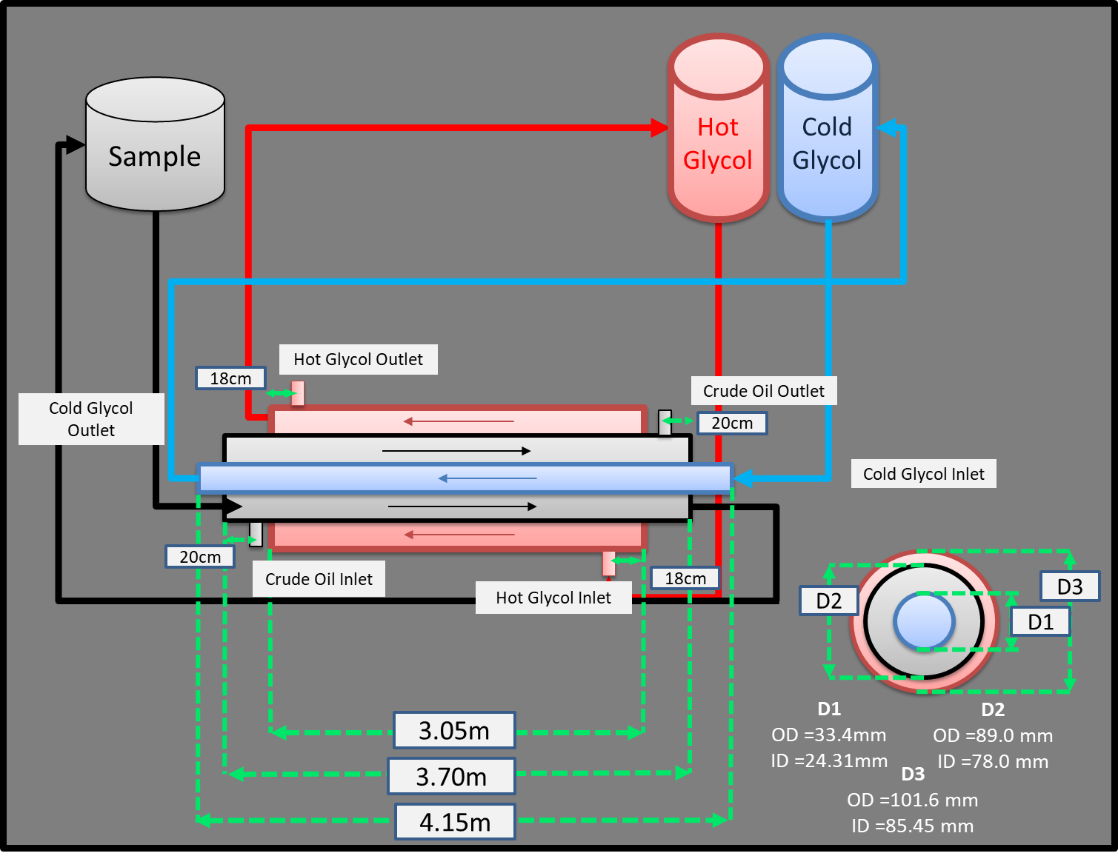

Figure 1. PRSB’s Wax Flow Loop Configuration and dimension

PRSB’s Wax Flow Loop Configuration and dimension

*T*c,i

*T*o,o

*m*c

*m*o

*m*h

*T*o,i

*T*h,i

*T*h,o

*L = 3m*

*T*c,o



*k*p = 14.4 W/m.K

Wax Deposit

*m*o

*m*c

*d*i

*d*w

Pipe

*T*c,i

*T*o,o

Oil Flow

*T*o,i

*T*c,o

Figure 2. Flow loop conversion into a normal pipeline

1. Graphical output (Sample)

Basically, the x-axis will be time since the flow loop test section is treated as single section only while the y-axis will be the output from the calculation. There are 3 outputs for level 1 – suppose to be 4, however, one of the output become an input as to make level 1 algorithm independent from level 2 and level 3 algorithms.